

To: City Executive Board
Council

Date: 3 July 2014
14 July 2014

Report of: Head of City Development

Title of Report: Capital Contribution towards Frideswide Square

Summary and Recommendations

Purpose of report: To agree to make a financial contribution to the County Council towards the work to transform Frideswide Square.

Key decision Yes

Executive lead member: Councillor Bob Price, Board Member for Corporate Strategy, Economic Development and Planning

Policy Framework: Corporate Plan - Vibrant and Sustainable Economy, West End Area Action Plan – more attractive spaces.

Recommendations: That City Executive Board

1. Recommend to full Council to give a capital grant to the County Council of £670,000 in two phases of £335,000 each (50% in Q3 2014/15 and 50% in Q2 2015/16).

2. Delegate to the Executive Director of Regeneration and Housing responsibility to complete the legal agreement requested by the County Council.

Context

- In the West Area Action Area Plan 2008 there is Policy WE 6 that promotes the improvement of Frideswide Square and the railway station forecourt to become more attractive, welcoming and better functioning spaces.

- The West End AAP also brought in a special S106 policy requirement that major developments in the West End should contribute to a single streamline S106 contribution fund.

- For a number of years the City and County Councils, together as part of the West End partnership, have been progressing a number of key West End projects including Frideswide Square, planning to transform Frideswide Square from a busy highway junction into a well-managed entry point to the city in keeping with the character of Oxford.

- Frideswide Square is of strategic importance in Oxford and Oxfordshire’s road network, handling tens of thousands of car, bus, cycle and pedestrian journeys every day. In particular, it is one of the key bottlenecks preventing reliable journey times for people commuting into Oxford.

- It is also the gateway to the area for rail passengers. Oxford rail station is one of the fastest growing stations in the country, with 50% growth in passenger numbers since 2003. An estimated 5.5 million people pass through the station each year. Frideswide Square is the main point of arrival and departure for people using the station.

- Transforming Frideswide Square is a vital part of the regeneration of Oxford’s West End, helping to ensure excellent access to major development sites such as the Westgate shopping centre and Oxpens.

- In early 2012, the County Council Cabinet approved the “Boulevard” option for detailed design and implementation. It considers that its bold and innovative approach proposed for Frideswide Square will help to set the tone for other projects and developments in the West End. The intention at the time was that construction would start early in 2013.

- At that meeting it was explained that the “Boulevard” option was preferred to the alternative “Oval” option, for the following reasons:

  - “Regeneration: the Boulevard provides larger open spaces connected to all three principal frontages, which will better help businesses occupying them prosper and contribute to a thriving square and wider West End regeneration.

  - Deliverability: unlike the Oval option, no land outside the highway boundary is required to deliver the Boulevard, avoiding a significant risk to deliverability.

  - Flexibility: this part of the city is expected to change significantly over the next ten years. It is impossible to predict exactly what form these changes will take. The Boulevard has greater inherent flexibility to accommodate changes around the square such as new buildings or new uses.

  - Stakeholder support: the Boulevard is supported by the majority of stakeholders. “

- At the time the City Council informally supported the Boulevard option and agreed that it would be willing to consider making a financial contribution towards the cost of the square from the West End S106 streamline contribution fund.

Proposal

- The County Council had originally hoped to have progressed with the project in early 2013. However, work then began on the new Station master plan through the three way partnership of City and County Councils with Network Rail. It soon became clear that an important part of the station project should be the replacement of the Botley Road bridge with a new wider and slightly deeper structure. This then had knock on implications for the Frideswide Square project both in terms of timing and design.

- More recently the County Council has decided to proceed with Frideswide Square on a programme with the following steps:

Detailed design: May - Oct 2014
Enabling works: Sept to Dec 2014
Main work: Feb to Dec 2015

- The County Council will consult the City Council on the detailed design of the square, seeking agreement through the Leaders Bi-lateral meeting. County officers have confirmed that they are working to a specification, materials and finishes that will be of high quality and not compromised. In addition the scheme will be presented to the Oxford Design Panel on about 17th June. A verbal update will be made to CEB on the views expressed by the Panel in its Report. There will also be an opportunity for the public to comment on the design later this year in August.

- The full cost of the project is £5.5 m The County Council has asked the City Council to make a contribution of £670,000. This money is available from a number of different sources in the City Council’s budgets. With this grant the County Council has confirmed that the project is now fully funded.

Source | Amount £
Capital Programme 2014/15 WE Partnership (M5014) | 217,225
Capital Programme 2015/16 WE Partnership (M5014) | 282,775
S106 extra WE Partnership not listed in Capital programme | 50,000
New Growth Points unallocated | 51,000
S106 Works of Art (West End) Said BS | 50,000
S106 Works of Art (other) | 19,000
Total | 670,000

- The County Council has indicated that it would wish to complete a formal legal agreement with the City Council so that the City Council can be reassured that its grant will be used for the purposes intended and in the timescales indicated and the County Council can be reassured that the City Council will make the payments on the dates agreed. This agreement will be able to stipulate that some of the grant is to be used towards an Arts strategy and public art. This agreement will also ensure that the City Council in return for offering this grant is invited to comment on the detailed design, through the regular Leaders Bi-Lateral meetings.

Level of Risk

- The proposal is to give a grant to the County Council, who will bear all of the risks for its project.

Climate Change / Environmental Impact

- There are no implications directly flowing from this report. However, the County Council’s design concept for the square seeks to ease the flow of traffic and also encourage cycling and pedestrian flows through the square. This design should reduce the climate change impacts of the motorised traffic currently using this busy junction.

Equalities impact

- As above, there are no implications directly flowing from this report. However, the County Council’s design concept for the square seeks to ease the flow of traffic and also encourage cycling and pedestrian flows through the square. Improving the ability of pedestrians, in particular, by making the square a more pleasant environment should meet equalities aspirations.

Financial implications

- As explained in the body of the report above, the finance involved is available in the Council’s capital programme and in unallocated S106 and New Growth Point funds. The proposal is to phase the payments to 50% in Q3 2014/15 and 50% in Q2 2015/16. The first payment on the letting of a contract for the works (likely to be in Q3 14/15) and the second one 6 months after the start of the construction (likely to be in Q2 15/16)

- £500, 000 of the £670,000 sought is already phased in the capital programme between these two financial years. Since this money is available from a number of different sources in the City Council’s budgets, it is necessary to ask CEB to recommend to full Council that £670,000 is identified as a grant to be paid to the County Council for this project.

- The level of grant is capped at £670,000. There has been no request that the City Council contribute to a proportion of the costs of the County Council’s project. Therefore the City Council will have no liability should the cost escalate. This point will be confirmed in the legal agreement.

Legal Implications

- A copy of the draft legal agreement (has been provided) by the County Council. The purpose of the agreement is to safeguard the interest of the City Council and ensure that the money is only paid across to the County Council at the appropriate stages and if not used or if the project is abandoned or altered to a much down-graded scheme will be returned to the City Council. Advice from legal officers is that

Name and contact details of author:-
Name: Michael Crofton Briggs
Job title: Head of City Development
Service Area / Department: City Development
Tel: 01865 2360 e-mail: mcrofton-briggs@oxford.gov.uk

List of background papers:

County Council Cabinet Report 13th March 2012

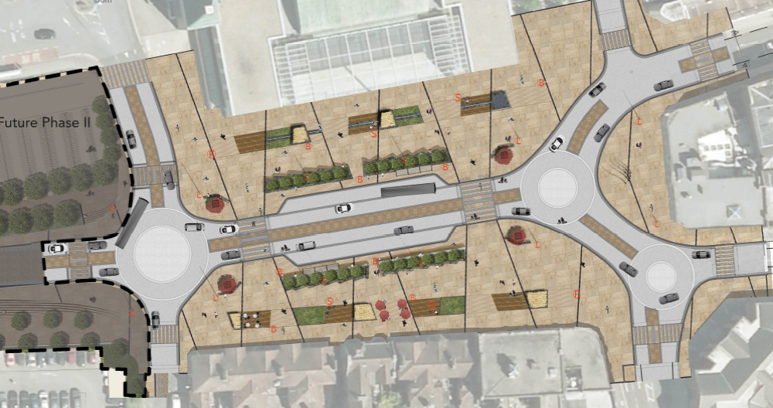
Source: Oxfordshire County Council 2012 Landscape design proposals for the Boulevard – currently being updated

